SIMULATION

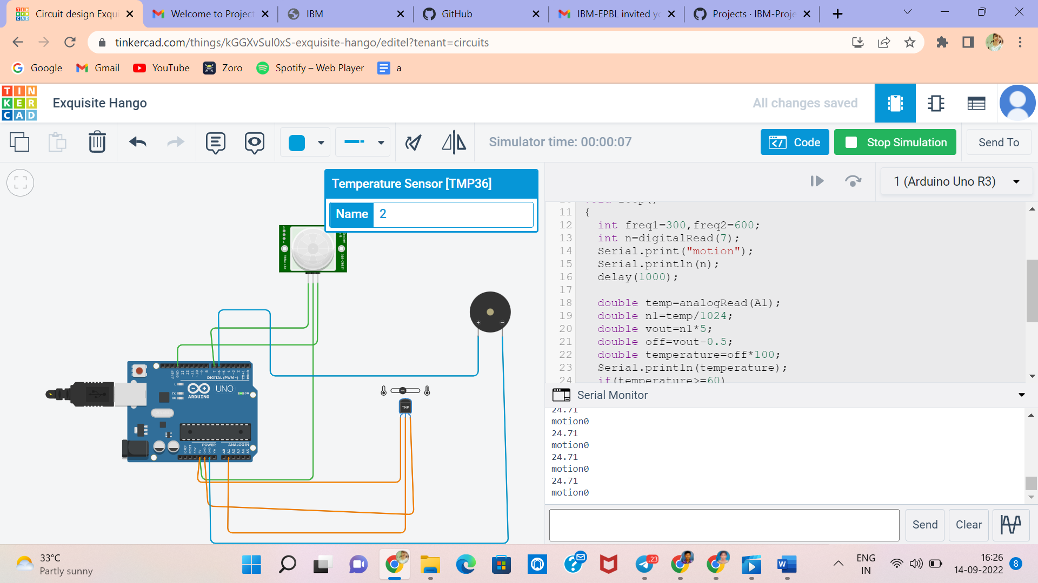

CODE
void setup()
{
Serial.begin(9600);
pinMode(7,INPUT);
pinMode(6,OUTPUT);
}
void loop()
{
int freq1=300,freq2=600;
int n=digitalRead(7);
Serial.print("motion");
Serial.println(n);
delay(1000);
double temp=analogRead(A1);
double n1=temp/1024;
double vout=n1*5;
double off=vout-0.5;
double temperature=off*100;
Serial.println(temperature);
if(temperature>=60)
{
tone(6,freq2,1000);
}
else if(n==1)
{
tone(6,freq1,1000);
}
}

